

**Team Members:- Team Leader:- Mohd Rihan Khan**

**Member 1: Sanjay Ishwar Dalawai Member 2: Abhijeet Kumar**

**Member 3: Mokhit Mahebub Khan Member 4: Yogesh Kumar Saini**

**PART - I**

**Product Dissection**

## **Platform Selection - PhonePe**

### **Question:**

Choose a leading platform from a domain related to the FinTech industry. Justify your selection by discussing the platform's popularity, impact, and relevance in its industry.

#### **Popularity**

* **PhonePe** is one of India's **leading digital payment platforms**, leveraging **Unified Payments Interface (UPI)** for seamless transactions. It has surpassed **500 million registered users** and processes **billions of transactions annually**.
* The platform is widely used for **peer-to-peer (P2P) money transfers, merchant payments, mobile recharges, utility bill payments, investment services, and insurance solutions**.
* PhonePe has gained a stronghold in **urban and rural markets** due to its user-friendly interface, multilingual support, and integration with small businesses.

#### 

#### **Impact**

* **PhonePe has revolutionized digital payments** by making transactions **cashless, instant, and secure**, reducing dependency on physical banking.
* It has driven **financial inclusion**, enabling millions of people, including small businesses and rural merchants, to adopt digital transactions.
* The app’s support for regional languages has further bridged the digital divide in India.
* The platform has significantly contributed to **India’s cashless economy**, supporting the Indian government’s **Digital India initiative**.
* PhonePe’s integration of **mutual funds, gold investments, insurance, and lending** has transformed it from a payment app into a **comprehensive financial services platform**.

#### **Relevance**

* In a world shifting towards **contactless and digital payments**, PhonePe is at the forefront of innovation in the **FinTech ecosystem**.
* Its **AI-powered risk management, personalized financial insights, and fraud detection mechanisms** ensure a **secure and seamless** transaction experience.
* PhonePe's adoption of **UPI AutoPay, cross-border remittances, and small-scale lending services** ensures its continued relevance in the evolving financial landscape.
* It also empowers both individuals and businesses with seamless digital payment solutions.

## **Core Features and Functionalities**

### **Question:**

Research and list the core features and functionalities of the selected platform. Describe how these features contribute to the platform’s success and user engagement.

### **Core Features and Functionalities of PhonePe**

**UPI-Based Payments**

* **Description**: Enables fast, real-time money transfers between bank accounts without requiring an account number or IFSC code. Zero transaction fees, ensuring accessibility for users across all income levels.
* **Contribution to Success:** Promotes widespread adoption due to convenience and cost-effectiveness, making digital payments accessible to a broad audience.

**Merchant Payments**

* **Description**: Seamless QR-code-based transactions for offline merchants and integrated checkout for e-commerce payments. Helps small businesses digitize their payment systems, reducing cash dependency.
* **Contribution to Success:** Supports local businesses and enhances the digital economy, increasing merchant and customer engagement.

**Integration with E-Commerce**

* **Description**: PhonePe is integrated with platforms like Flipkart, allowing seamless purchases.
* **Contribution to Success**: Integration enhances convenience, boosting user engagement and driving revenue.

**Bill Payments & Recharges**

* **Description**: Users can pay electricity, water, gas, DTH, broadband, and credit card bills in one place. Supports AutoPay for recurring payments, improving financial convenience.
* **Contribution to Success:** Simplifies everyday financial tasks, increasing user satisfaction and retention.

**Investments & Wealth Management**

* **Description**: Offers mutual funds, SIPs, digital gold, and fixed deposits for users to grow their savings. Smart recommendations based on spending patterns encourage better financial planning.
* **Contribution to Success:** Empowers users to manage and grow their wealth, enhancing user engagement and loyalty.

**Insurance Services**

* **Description**: Provides health, life, travel, and vehicle insurance with AI-driven risk assessment. Instant policy issuance and claims tracking for a hassle-free experience.
* **Contribution to Success**: Adds value by offering comprehensive financial protection, making PhonePe a one-stop solution for financial needs.

**Instant Personal Loans**

* **Description**: Offers small-ticket credit (BNPL - Buy Now, Pay Later) and micro-lending solutions. Uses AI-powered credit scoring to assess risk and determine loan eligibility.
* **Contribution to Success:** Increases financial inclusion and flexibility for users, boosting app usage and trust.

**Multi-Language Support**

* **Description**: Available in over 11 Indian languages, increasing accessibility for non-English speakers.
* **Contribution to Success:** Broadens user base by catering to diverse linguistic needs, enhancing user experience and inclusivity.

**Fraud Detection & Security**

* **Description**: Uses AI and machine learning to detect fraudulent transactions, preventing cyber threats. Offers two-factor authentication (2FA) and UPI PIN protection for enhanced security.
* **Contribution to Success:** Builds user trust by ensuring secure transactions, increasing app reliability.

**Customer Engagement and Rewards**

* **Description**: Scratch cards, cashback offers, and rewards programs incentivize transactions. Gamification of financial activities keeps users engaged.
* **Contribution to Success:** Encourages frequent app usage and user loyalty through rewarding experiences.

**Cross-Border Transactions**

* **Description**: PhonePe is expanding into international payments, allowing users to make UPI transactions abroad.
* **Contribution to Success**: Enhances utility for users traveling internationally, broadening PhonePe's appeal and functionality.

**Transaction History and Insights**

* **Description**: Users can view detailed transaction history and spending analytics.
* **Contribution to Success**: This feature builds trust and helps users manage their finances effectively, increasing app reliability.

### **Contribution to Success and User Engagement**

* **Ease of Use:** Simple **one-tap payments** make digital transactions **frictionless**.
* **Trust & Security:** Strong fraud prevention mechanisms build **user confidence**.
* **Financial Inclusion:** Enables rural users and small businesses to participate in the digital economy.
* **Comprehensive Ecosystem:** Users **stay engaged** by managing all financial activities in one app.

### **Real-World Problems Addressed by PhonePe**

**Lack of Access to Banking Services in Remote Areas**

* **Problem**: Many people in rural areas lack access to traditional banking infrastructure.
* **Solution**: PhonePe enables users to perform digital transactions directly from their bank accounts through UPI, eliminating the need for physical bank visits. Its multi-language support makes it accessible to users across diverse regions.

**Cash Dependency and Inefficiency in Payments**

* **Problem**: Cash transactions are unmanageable and unsafe, and limit financial transparency.
* **Solution**: PhonePe promotes cashless payments with QR code-based merchant transactions, peer-to-peer transfers, and online payments, reducing the need for physical cash.

**Challenges with Bill Payments and Recharges**

* **Problem**: Paying bills and recharging services often involve long queues or multiple apps.
* **Solution**: PhonePe consolidates these services into one platform, allowing users to pay bills and recharge instantly, saving time and effort.

**Financial Literacy and Investment Barriers**

* **Problem**: Many people find it difficult to access and understand investment and insurance products.
* **Solution**: PhonePe simplifies access to mutual funds, digital gold, and insurance plans, encouraging financial literacy and empowering users to grow their wealth.

**High Costs of Traditional Payment Methods**

* **Problem**: Debit/credit card transactions often incur fees, making them less viable for small transactions.
* **Solution**: PhonePe’s UPI-based payments are free, making it cost-effective for both users and businesses.

**Lack of Digital Payment Options for Small Businesses**

* **Problem**: Small vendors and shops often do not have access to expensive point-of-sale systems.
* **Solution**: PhonePe provides an easy-to-use QR code-based system for merchants, enabling them to accept payments without additional costs.

**Inconvenience of Using Multiple Apps**

* **Problem**: Users often need multiple apps for food delivery, travel booking, and shopping.
* **Solution**: The PhonePe Switch feature integrates multiple services into one platform, enhancing convenience and reducing app fatigue.

**Trust Issues with Digital Payments**

* **Problem**: Many users are hesitant to trust digital payments due to concerns about fraud and data security.
* **Solution**: PhonePe ensures secure transactions with bank-grade encryption, multi-factor authentication, and transparent transaction records, building user trust.

**Unorganized Personal Finances**

* **Problem**: People struggle to keep track of their spending and manage their finances.
* **Solution**: PhonePe’s transaction history and analytics provide insights into spending patterns, helping users manage their money effectively.

**Limited Investment & Credit Access**

* Problem: Many Indians lack access to investment opportunities and formal credit, limiting wealth growth.
* Solution: Micro-investment options like gold, mutual funds, and fixed deposits allow users to grow their savings. AI-powered instant personal loans provide access to credit without traditional collateral requirements.

**Database Management & Schema Design**

### **4. Schema Design**

**Question:** Based on the features and functionalities you have identified, design a schema that reflects the platform’s data structure. Define the key entities, attributes, and relationships that underpin these features.

**Answers: Schema Design for PhonePe**

The schema design for PhonePe should reflect its core features and functionalities, ensuring efficient data management and enabling the platform to deliver a seamless user experience.

Below is an overview of the key entities, attributes, and relationships:

**Users:-** Stores basic user information such as full name, email, mobile number, hashed password, registration timestamp, KYC status, and referral details. This is the central entity for the platform.

| Column Name | Data Type | Description |
| --- | --- | --- |
| user_id | BIGINT (PK) | Unique identifier for each user |
| full_name | VARCHAR(150) | Full name of the user. |
| email | VARCHAR(150) | Email address (unique). |
| mobile_number | VARCHAR(20) | Registered mobile number (unique). |
| password_hash | TEXT | Securely stored password hash. |
| registration_dt | TIMESTAMP | Timestamp of account creation. |
| kyc_status | ENUM(‘pending’,‘verified’,‘failed’) | KYC verification status |
| referral_code | VARCHAR(50) | Unique referral code for the user. |
| referred_by | BIGINT (FK) | user_id of the referrer (if any). |

**Bank_Accounts:-** Records details of each user's linked bank account (bank name, account number, IFSC code, account type, and verification status) and ties each record to a user via a foreign key.

| Column Name | Data Type | Description |
| --- | --- | --- |
| account_id | BIGINT (PK) | Unique bank account record ID. |
| user_id | BIGINT (FK) | Associated user. |
| bank_name | VARCHAR(100) | Name of the bank. |
| account_number | VARCHAR(50) | Encrypted bank account number. |
| ifsc_code | VARCHAR(20) | Bank’s IFSC code. |
| account_type | VARCHAR(20) | Type (Savings, Current, etc.). |
| verification_status | ENUM('pending','verified','failed') | Status of account verification. |
| created_at | TIMESTAMP | TIMESTAMP when the account was created. |

**Wallets:-** Maintains each user’s digital wallet balance, currency (defaulting to INR), and last updated time. It links directly to the Users table.

| Column Name | Data Type | Description |
| --- | --- | --- |
| wallet_id | BIGINT (PK) | Unique wallet identifier. |
| user_id | BIGINT (FK) | Owner’s user ID. |
| balance | DECIMAL(15,2) | Current wallet balance. |
| currency | VARCHAR(10) | Currency code (e.g., INR). |
| last_updated | TIMESTAMP | Timestamp of last balance update. |

**Referral_Rewards:-** Log rewards are given when one user refers to another. It stores the IDs of the referrer and referee, the reward amount, the type, and the date awarded.

| Column Name | Data Type | Description |
| --- | --- | --- |
| reward_id | BIGINT (PK) | Unique reward record. |
| referrer_id | BIGINT (FK) | User ID of the person who referred. |
| referee_id | BIGINT (FK) | New user’s ID (if applicable). |
| reward_amount | DECIMAL(10,2) | Reward value credited. |
| reward_type | VARCHAR(50) | Type of reward (e.g., “referral bonus”). |
| awarded_at | TIMESTAMP | Timestamp when the reward was granted. |

**UPI_Transactions:-** Captures the details of money transfers between users (or to external UPI platforms), including sender, receiver, amount, currency, payment method, status, timestamps, and reference number.

| Column Name | Data Type | Description |
| --- | --- | --- |
| transaction_id | BIGINT (PK) | Unique transaction identifier. |
| sender_id | BIGINT (FK) | User ID of the sender. |
| receiver_id | BIGINT (FK) | User ID of the receiver or external UPI identifier. |
| amount | DECIMAL(15,2) | Transaction amount. |
| currency | VARCHAR(10) | Currency (e.g., INR). |
| payment_method | ENUM('UPI','Wallet') | Method used for the transaction. |
| status | ENUM('pending','success','failed') | Transaction Status |
| created_at | TIMESTAMP | Timestamp of transaction initiation. |
| updated_at | TIMESTAMP | Timestamp of last update (e.g., settlement time). |
| reference_no | VARCHAR(100) | External or internal reference number. |

**Bill_Payments:-** A general table for various bill-related transactions (recharge, subscriptions, donations, financial services, etc.). It stores the transaction amount, status, method, transaction date, and additional service details (optionally linked via a service_id).

| Column Name | Data Type | Description |
| --- | --- | --- |
| bill_id | BIGINT (PK) | Unique bill payment record. |
| user_id | BIGINT (FK) | The user who made the payment. |
| service_id | BIGINT (FK) | Reference to Service category. |
| category | VARCHAR(50) | Broad category: 'Recharge', 'Utility', 'Subscription', 'Donation', 'Financial', 'More'. |
| sub_category | VARCHAR(50) | More specific type (e.g., within Utility: ‘electricity’, ‘water’, ‘gas’, ‘postpaid’, etc.). |
| amount | DECIMAL(15,2) | Payment amount. |
| status | ENUM('pending','success','failed') | Payment status. |
| payment_method | VARCHAR(50) | Payment method used (e.g., UPI, wallet, card). |
| transaction_date | TIMESTAMP | Date and time of payment. |
| vendor_id | BIGINT (FK, NULLABLE) | Optional link to a vendor (e.g., telecom provider, utility). |
| additional_info | JSON | Flexible field for extra details (like bill number, subscription period, donation type, etc.). |

**Insurance_Purchases:-** Contains records of insurance policy purchases (policy number, type, premium amount, policy dates, status, and extra details) linked to the purchasing user.

| Column Name | Data Type | Description |
| --- | --- | --- |
| insurance_id | BIGINT (PK) | Unique insurance purchase record. |
| user_id | BIGINT (FK) | Buyer’s user ID. |
| policy_number | VARCHAR(100) | Unique policy number. |
| insurance_type | VARCHAR(50) | e.g., 'Bike', 'Car', 'Health', 'Term Life', 'ULIP', 'Travel', 'Accident', etc. |
| premium_amount | DECIMAL(15,2) | Premium paid. |
| start_date | DATE | Policy start date. |
| end_date | DATE | Policy expiry date. |
| status | ENUM('active','expired','lapsed') | Policy status. |
| next_due_date | DATE (NULLABLE) | Next premium due date (if applicable). |
| created_at | TIMESTAMP | Purchase timestamp. |
| additional_details | JSON | Extra info (beneficiary, coverage, etc.). |

**Insurance_Premium_Payments:-** Tracks premium payments made on existing insurance policies, storing the payment amount, date, status, method, and any remarks.

| Column Name | Data Type | Description |
| --- | --- | --- |
| premium_payment_id | BIGINT (PK) | Unique record for a premium payment. |
| insurance_id | BIGINT (FK) | Reference to the policy purchased. |
| payment_amount | DECIMAL(15,2) | Premium payment amount. |
| payment_date | TIMESTAMP | Date/time of the premium payment. |
| status | ENUM('pending','success','failed') | Payment status. |
| payment_method | VARCHAR(50) | Method used (e.g., UPI, wallet). |
| remarks | VARCHAR(255) (NULLABLE) | Optional details. |

**Investments:-** Holds user investment information, such as the type and sub-type of investment (e.g., SIP, mutual funds), amounts invested, current value, start and maturity dates, and status.

| Column Name | Data Type | Description |
| --- | --- | --- |
| investment_id | BIGINT (PK) | Unique investment record. |
| user_id | BIGINT (FK) | Investor’s user ID. |
| product_type | VARCHAR(50) | e.g., 'SIP', 'Mutual Fund', 'Gold', '3-in-1 Fund', 'Tax Saving Fund', etc. |
| product_sub_type | VARCHAR(50) | More specific sub-type (e.g., within Mutual Funds: 'Large Cap', 'Mid Cap', etc.). |
| investment_amount | DECIMAL(15,2) | Amount invested. |
| current_value | DECIMAL(15,2) | Current valuation (if applicable). |
| start_date | DATE | Date when investment started. |
| maturity_date | DATE (NULLABLE) | For investments with a fixed tenure. |
| status | ENUM('active','matured','liquidated') | Current status. |
| created_at | TIMESTAMP | Timestamp of record creation. |
| additional_info | JSON | Extra details, e.g., fund manager, scheme details. |

**Travel_Bookings:-** Stores travel-related bookings (flights, buses, trains, hotels, etc.) with details like travel mode, vendor (if any), itinerary (in JSON), amount, and booking status.

| Column Name | Data Type | Description |
| --- | --- | --- |
| booking_id | BIGINT (PK) | Unique booking identifier. |
| user_id | BIGINT (FK) | The user making the booking. |
| travel_mode | ENUM(‘metro’,'flight','bus','train','hotel','cab','airport_cab','travel_activity','visa','travel_insurance') | Mode or service booked. |
| vendor_id | BIGINT (FK, NULLABLE) | Optional reference to travel service provider. |
| booking_details | JSON | Contains details like itinerary, seat numbers, hotel name, dates, etc. |
| amount | DECIMAL(15,2) | Total booking amount. |
| status | ENUM('pending','confirmed','cancelled') | Booking status. |
| booked_at | TIMESTAMP | Timestamp when booking was made. |

**Purchase_Orders:-** Logs e‑commerce transactions (digital gold, daily saving, app purchases, brand vouchers) including purchase details, amount, and payment status. It can also reference a standardized service category.

| Column Name | Data Type | Description |
| --- | --- | --- |
| purchase_id | BIGINT (PK) | Unique purchase order ID. |
| user_id | BIGINT (FK) | Buyer’s user ID |
| service_id | BIGINT (FK) | link to Service_Categories for standardized categorization |
| purchase_category | ENUM('digi_gold','daily_saving','app_purchase','brand_voucher') | Category of purchase. |
| item_details | JSON | Details of the item or service purchased. (For apps, voucher codes, etc.) |
| amount | DECIMAL(15,2) | Purchase amount. |
| payment_status | ENUM('pending','success','failed') | Payment status. |
| purchase_date | TIMESTAMP | Timestamp of purchase. |

**Vendors:-** Acts as a lookup for external service providers (telecom, utility, travel, food, etc.). It stores vendor names, categories, contact details, and website information.

| Column Name | Data Type | Description |
| --- | --- | --- |
| vendor_id | BIGINT (PK) | Unique vendor identifier. |
| vendor_name | VARCHAR(150) | Name of the vendor or service provider. |
| category | VARCHAR(50) | Category of vendor (e.g., telecom, utility, travel, food, insurance, etc.). |
| contact_details | JSON | Contact and address information. |
| website | VARCHAR(255) | Vendor website (if applicable). |

**Service_Categories:-** Serves as a master list of service types (e.g., Bill Payment, Insurance, Wealth, Travel) that can be referenced by other tables (like Bill_Payments and Purchase_Orders) to ensure consistent categorization.

| Column Name | Data Type | Description |
| --- | --- | --- |
| service_id | BIGINT (PK) | Unique service category identifier. |
| service_name | VARCHAR(100) | Name of the service (e.g., “Money Transfer”, “Bill Payment”, “Insurance”, “Wealth”, “Travel”, “Metro”, “Purchase”). |
| description | TEXT | Description of the service. |

**Relationship Table:-**

| Relationship | Parent table | Child Table | Foreign Key(s) in Child | Cardinality |
| --- | --- | --- | --- | --- |
| **User to Bank Accounts** | Users | Bank_Accounts | user_id | One-to-Many |
| **User to Wallets** | Users | Wallets | user_id | One-to-One |
| **User to Referral Rewards (as referrer)** | Users | Referral_Rewards | referrer_id | One-to-Many |
| **User to Referral Rewards (as referee)** | Users | Referral_Rewards | referee_id | One-to-Many |
| **User to UPI Transactions (Sender)** | Users | UPI_Transactions | sender_id | One-to-Many |
| **User to UPI Transactions (Receiver)** | Users | UPI_Transactions | receiver_id | One-to-Many |
| **User to Bill Payments** | Users | Bill_Payments | user_id | One-to-Many |
| **Bill Payments to Service Categories (optional link)** | Service_Categories | Bill_Payments | service_id | One-to-Many (Optional) |
| **Bill Payments to Vendors (optional link)** | Vendors | Bill_Payments | vendor_id (nullable) | One-to-Many (Optional) |
| **User to Insurance Purchases** | Users | Insurance_Purchases | user_id | One-to-Many |
| **Insurance Purchases to Premium Payments** |  | Insurance_Premium_Payments | insurance_id | One-to-Many |
| **User to Investments** | Users | Investments | user_id | One-to-Many |
| **User to Travel Bookings** | Users | Travel_Bookings | user_id | One-to-Many |
| **Travel Bookings to Vendors (optional link)** | Vendors | Travel_Bookings | vendor_id (nullable) | One-to-Many (Optional) |
| **User to Purchase Orders** | Users | Purchase_Orders | user_id | One-to-Many |
| **Purchase Orders to Service Categories (optional link)** | Service_Categories | Purchase_Orders | service_id (optional) | One-to-Many (Optional) |

This schema design captures the essential data interactions and relationships within PhonePe, seamlessly supporting its diverse functionalities—from UPI transactions and wallet management to bill payments, insurance, investments, and travel services. It ensures robust data integrity, scalability, and high performance while delivering a personalized user experience, thereby laying a solid foundation for rapid innovation and overall platform success.

### **5. ER Diagram Creation**

**Question:** Utilise tools like the Miro platform or similar applications to create an illustrative Entity-Relationship (ER) diagram. This diagram should vividly depict the entities, attributes, and relationships present within your schema design.

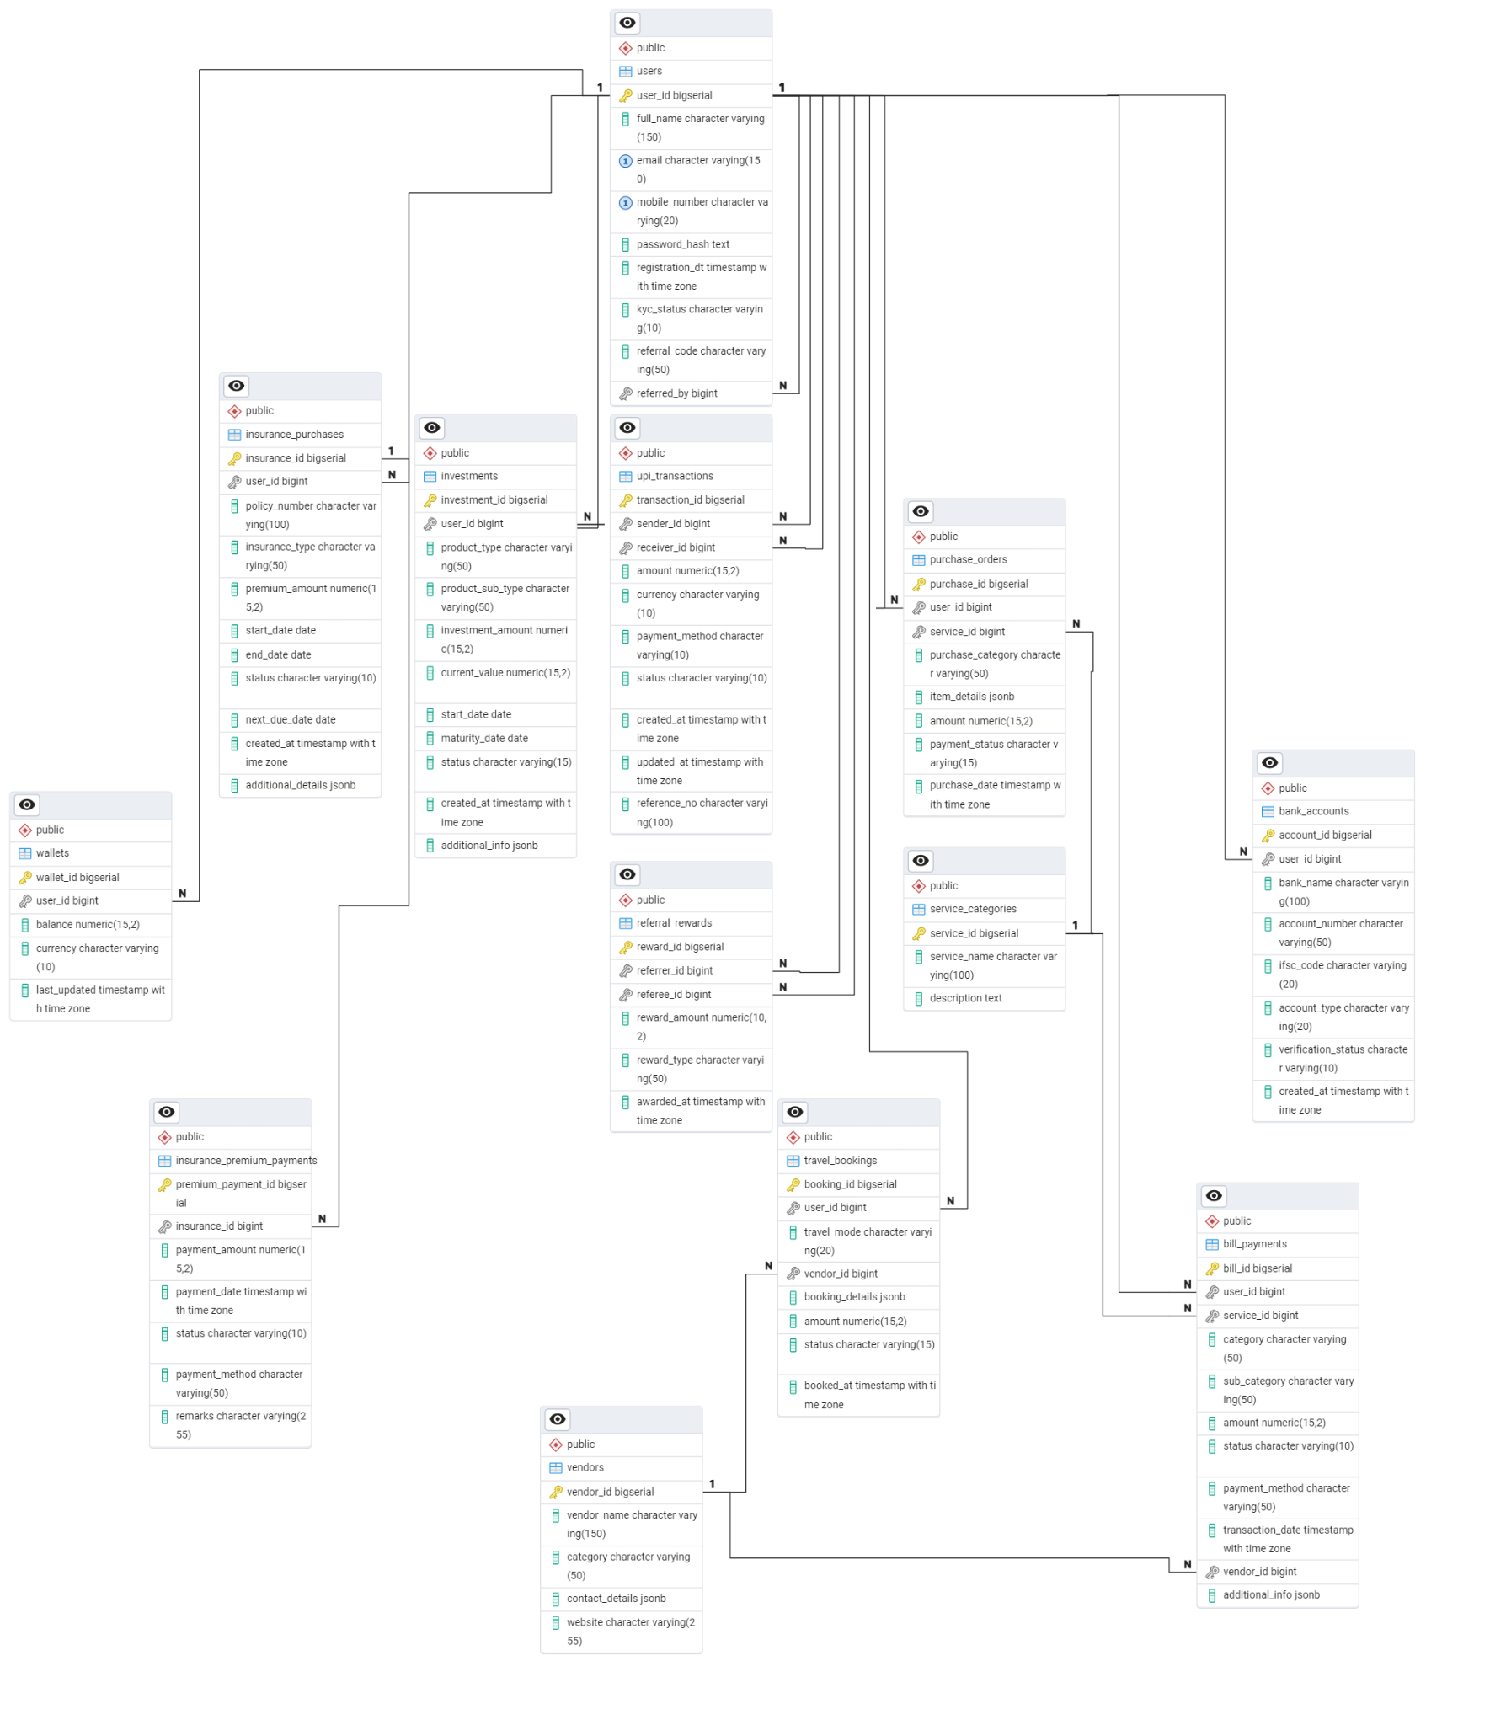

**Revenue and Profit Growth Strategies**

**Question:** After completing the product dissection and schema design steps for the chosen platform, conduct a comprehensive case study on the above-chosen industry. Your goal is to identify and propose strategies to increase the **profit of the industry by at least 25%**.

Create a detailed report summarising your findings and proposals. Include data-driven justifications for each proposed strategy and present your case study using visual aids such as charts, graphs, and diagrams to illustrate your points. Outline the steps, resources, and timeline required to achieve the desired revenue and profit growth.

1. **Analysing PhonePe's Current Status**

To find the status of PhonePe and develop a strategy to increase its profit by 25%, we have conducted a thorough analysis of the company's current scenario. This includes examining its current profit, understanding the sources of revenue and expenses, and analyzing customer acquisition and retention.

1. **Current Financial Data -**

**Revenue**

| Revenue Stream | Description | Estimated Contribution (%) |
| --- | --- | --- |
| UPI Payment Processing (MDR - Merchant Discount Rate) | PhonePe earns from merchants via UPI transactions (but MDR is waived for P2P transfers). | ~30% |
| Bill Payments & Recharges | Commission on electricity, water, broadband, DTH, gas, and mobile recharges. | ~10% |
| Financial Services | Includes mutual funds, gold investments, insurance, and lending products. Earns commissions & fees. | ~20% |
| Payment Gateway Services | Charges merchants for using its payment gateway solutions (PhonePe Payment Gateway). | ~15% |
| Lending & Buy Now, Pay Later (BNPL) | Interest & fees from consumer and merchant lending, including PhonePe Loan Services. | ~10% |
| Advertising & Partnerships | Revenue from brands running promotions, banners, a the PhonePe app.nd targeted ads on | ~5% |
| Offline Merchant Solutions | Rental fees & commissions from PoS (Point-of-Sale) machines & QR code solutions for offline businesses. | ~5% |
| Cross-Border Payments | Fees from international transactions & remittances. | ~5% |

**Expenses**

| Expense Category | Description | Estimated Share (%) |
| --- | --- | --- |
| Customer Acquisition & Marketing | Heavy spending on cashback offers, referral rewards, and promotions. | ~30% |
| Technology & Infrastructure | Server costs, cloud storage, AI/ML capabilities, and cybersecurity investments. | ~20% |
| Employee Salaries & Operations | Salaries for engineers, analysts, customer support, and business development. | ~15% |
| Banking & Network Fees | Fees paid to banks and payment networks (NPCI) for UPI transactions. | ~15% |
| Compliance & Regulatory Costs | Licensing fees, audits, and compliance with RBI & NPCI regulations. | ~10% |
| Merchant Incentives & Partnerships | Discounts, commission payouts, and partnerships with offline & online merchants. | ~10% |

**Profit & Loss**

| Category | Revenue (Estimated %) | Expenses (Estimated %) | Profit/Loss (Estimated %) |
| --- | --- | --- | --- |
| UPI Payment Processing | 30 | 15 (Banking & Network) | 15 |
| Bill Payments & Recharges | 10 | 0 (Assumed low cost) |  |
| Financial Services | 20 | 0 (Assumed low cost) | 20 |
| Payment Gateway Services | 15 | 10 (Tech & Infra, some operations) | 5 |
| Lending & BNPL | 10 | 5 (Part of Tech & Infra, Operations, Risk) | 5 |
| Advertising & Partnerships | 5 | 10 (Marketing, Partnerships) | -5 |
| Offline Merchant Solutions | 5 | 5 (Operations, some marketing) | 0 |
| Cross-Border Payments | 5 | 5 (Compliance, Network) | 0 |
| Total | 100 | 60 | 40 |

**Profit Trends**

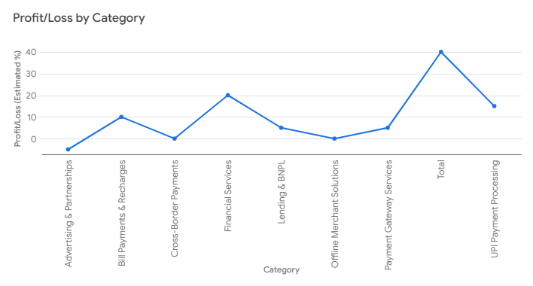

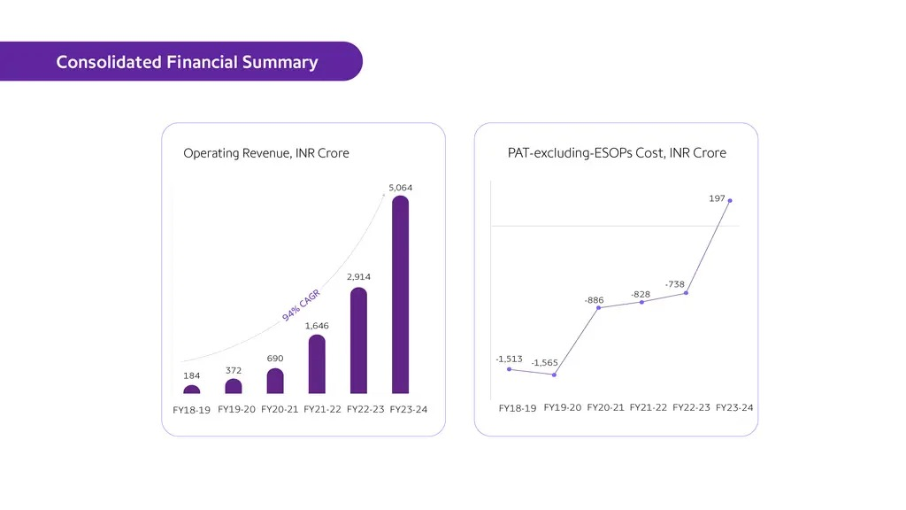

1. **Sources of Revenue**
2. **Core Payments Business (95% of Revenue)**

PhonePe’s primary source of revenue comes from its **payment processing services**, especially for merchants.

* **Merchant Discount Rate (MDR)**:
  + PhonePe charges merchants a small percentage or flat fee for processing payments made via UPI, debit/credit cards, or wallets.
  + Larger businesses and high-value transactions incur MDR fees, while small businesses often enjoy free or subsidized services to encourage adoption.
* **Payment Gateway Services**:
  + Online merchants and e-commerce platforms use PhonePe’s gateway to accept payments, for which PhonePe charges transaction fees.

1. **Interest Income (₹661 crore in FY24)**

PhonePe earns significant interest from the funds it holds in its accounts.

* **Deposits**:
  + The platform temporarily holds user balances during transactions and earns interest on these deposits.
* **Investments**:
  + Investments in financial instruments like fixed deposits or mutual funds generate additional income.

1. **Insurance and Investment Products**

PhonePe offers financial products directly through its platform and earns a commission for every transaction.

* **Insurance**:
  + The platform provides insurance policies such as health, travel, and motor insurance in partnership with insurance companies.
* **Investments**:
  + Users can invest in mutual funds and buy digital gold through PhonePe, with PhonePe earning a small percentage as commission.

### **d. Value-Added Services for Merchants**

PhonePe offers merchants tools and services that help them manage their businesses better, for which it charges fees.

* **Business Analytics**:
  + Merchants can access data insights, transaction trends, and customer analytics.
* **Promotional Tools**:
  + Merchants pay for advertising within the PhonePe app, such as featured listings and offers.
* **QR Code Branding**:
  + Merchants can opt for premium QR codes with branding and additional features, which are chargeable.

### **e. Advertising Revenue**

PhonePe monetizes its vast user base by offering advertising slots on its platform.

* **In-App Promotions**:
  + Brands and merchants pay to feature their products, services, or offers in the PhonePe app.
* **Sponsored Listings**:
  + Merchants or partners can promote their services under PhonePe Switch, the platform’s mini-app ecosystem.

### 

### 

### **f. Lending Services**

PhonePe partners with financial institutions to offer lending services to users and merchants.

* **Small Loans for Merchants**:
  + Merchants can access short-term credit through PhonePe. The platform earns a commission for facilitating these loans.
* **Consumer Loans**:
  + Users can avail of “Buy Now Pay Later” (BNPL) or other credit services, generating additional revenue.

### 

### 

### 

### **g. Subscription Services**

PhonePe offers subscription-based services for enhanced features.

* Merchants can subscribe to advanced settlement features, additional analytics, and exclusive promotional campaigns.

### **h. PhonePe Switch**

This feature integrates third-party apps (e.g., Swiggy, Ola, MakeMyTrip) into the PhonePe ecosystem.

* **Revenue Model**:
  + PhonePe earns a share of the revenue generated through transactions made on these mini-apps.

1. **Sources of Expenses**

**i. Customer Acquisition & Marketing (~30%)**

1. **Cashback Offers**: PhonePe spends heavily on cashback campaigns to attract and retain users.
2. **Referral Rewards:** Incentives for users who refer others to join and use the platform.
3. **Advertising Campaigns:** Expenses on advertisements to increase brand visibility and user base.
4. **Promotions**: Other marketing strategies to penetrate new markets and sustain user engagement.

**ii. Technology & Infrastructure (~20%)**

1. **Server Costs**: Maintaining and scaling servers to handle millions of daily transactions.
2. **Cloud Storage**: Costs associated with storing user and transactional data securely.
3. **Cybersecurity Investments:** Ensuring secure transactions and protecting user data from fraud.
4. **AI/ML Capabilities:** Spending on Artificial Intelligence and Machine Learning for fraud detection, predictive analysis, and process optimization.

**Employee Salaries & Operations (~15%)**

1. **Salaries**: Payment to engineers, data analysts, customer support staff, and business development teams.
2. **Operational Costs:** Day-to-day business operations and administrative expenses.

**Banking & Network Fees (~15%)**

1. **Banking Fees:** Payments to banks for processing UPI and other types of financial transactions.
2. **NPCI Fees:** Charges paid to NPCI (National Payments Corporation of India) for UPI network usage and processing.

**Compliance & Regulatory Costs (~10%)**

1. **Licensing Fees:** Costs incurred to maintain licenses required by regulatory authorities like RBI and NPCI.
2. **Audits**: Regular financial and security audits to ensure compliance with laws.
3. **Legal & Compliance:** Expenses for adhering to industry standards and regulatory guidelines.

**Merchant Incentives & Partnerships (~10%)**

1. **Discounts for Merchants:** Providing discounts to incentivize merchants to accept payments through PhonePe.
2. **Commission Payouts:** Payments made to merchants as part of commission agreements.
3. **Partnership Development:** Costs associated with forming alliances with offline and online merchants to boost the ecosystem.

### 

### **4. Customer Acquisition & Retention Analysis for PhonePe**

### **Customer Acquisition Channels**

#### **1. Channels**

* **Social Media Platforms**:
  + Platforms like Facebook, Instagram, and Twitter are used to run targeted ads and campaigns.
  + PhonePe also engages in influencer marketing to enhance visibility.
  + Campaigns are optimized for specific demographics and regions.
* **Search Engines**:
  + Search Engine Marketing (SEM) through platforms like Google Ads brings in users searching for payment solutions.
  + Search Engine Optimization (SEO) ensures PhonePe ranks high for relevant keywords like "UPI payment app" or "best payment app in India."
* **Referral Programs**:
  + PhonePe incentivizes existing users to refer the app to others by offering rewards like cashback or discount coupons.
  + Referral campaigns are tailored to both merchants and customers to expand the user base.
* **Advertising Campaigns**:
  + Offline and online campaigns include TV commercials, billboards, and digital banners to attract a wide audience.
  + Sponsorships for major events or shows (e.g., IPL partnerships) provide mass outreach and increase downloads.

#### **2. Effectiveness**

* **Acquisition Cost Analysis**:
  + **Social Media Ads**: While these are cost-effective for specific demographics, frequent optimization is needed to reduce cost-per-acquisition (CPA).
  + **Search Engine Ads**: Slightly higher CPA but useful for attracting high-intent users.
  + **Referral Programs**: Highly effective due to the trust factor between referrer and new users, resulting in better retention rates.
  + **Advertising Campaigns**: Expensive but increases mass visibility and credibility.
* **Customer Conversion Rates**:
  + Track which channels lead to the highest downloads and user activations.
  + Compare costs of each campaign to ensure budget allocation aligns with ROI.
  + Evaluate campaign effectiveness using metrics like CTR (Click-Through Rate) and CAC (Customer Acquisition Cost).

### **Understanding Customer Behaviour and Retention**

#### **1. Customer Data Analysis**

* **Purchase and Transaction History**:
  + Track the frequency of transactions, average transaction value, and preferred payment modes (e.g., UPI, wallet, or card).
  + Segment users into categories such as high-frequency users, occasional users, and dormant users.
* **Browsing Patterns**:
  + Analyze how users navigate through the app—features they explore (e.g., bill payments, QR payments) and sections they abandon.
  + Identify bottlenecks like confusing UI/UX or unresponsive features.
* **Feedback Collection**:
  + Use in-app surveys, app store reviews, and customer support interactions to gather insights into user pain points and expectations.
  + Address recurring issues like failed transactions, delays, or complex app navigation.

#### 

#### 

#### **2. Retention Rates**

* **Calculation of Retention Rates**:
  + Retention Rate = [(Users at the end of the period - New Users Acquired) / Users at the start of the period] * 100
  + Measure this monthly, quarterly, and annually to identify trends.
* **Loyalty Drivers**:
  + Cashback and offers for repeat transactions encourage loyalty.
  + Exclusive perks like zero transaction fees for frequent users or early access to new features.
* **Segmentation of Retained Users**:
  + Retain users by targeting specific groups with personalized offers.
  + For example, offer free insurance for high-value users or loyalty rewards for merchants.

#### **3. Churn Analysis**

* **Reasons for Churn**:
  + **Technical Issues**: Failed or delayed transactions, app crashes, and poor network handling.
  + **Competitor Attraction**: Users lured by higher cashback or better offers from competitors like Google Pay or Paytm.
  + **Lack of Engagement**: Dormant users who haven’t received personalized offers or reminders.
* **Strategies to Reduce Churn**:
  + **Technical Improvements**: Optimize app performance and ensure transactions are seamless even in low-network areas.
  + **Engagement Campaigns**: Send personalized notifications and offers based on user activity.
  + **Reactivation Campaigns**: Offer exclusive benefits to users who haven’t transacted in a while.
  + **Customer Support Enhancements**: Proactively resolve issues and ensure prompt assistance through 24/7 support.

### 

### 

### 

### 

### 

### 

### **II. Focus Areas for Increasing PhonePe’s Profit by 25%**

To increase PhonePe's profit by 25%, the company must strategically focus on several key areas. These focus areas include internal management, product strategy, market expansion, Customer Engagement, and branding. By addressing these areas with targeted initiatives, PhonePe can enhance its operational efficiency, customer satisfaction, and market reach.

| **Focus Area** | **Subcategory** | **Contribution** | **Description** |
| --- | --- | --- | --- |
| **Internal Management** | Operational Efficiency | 6.50% | Cost reduction directly impacts the bottom line. Optimizing cloud usage, automating processes, and negotiating better vendor deals are classic strategies for squeezing more profit from existing operations. |
|  | Employee Productivity | 1.50% | A more efficient workforce translates to higher output and potentially lower labor costs per transaction. This is a smaller contributor, but still important. |
|  | Fraud Prevention | 2% | Fraud is a direct drain on profits. Investing in robust prevention measures not only protects customers but also avoids significant financial losses, making this a high-impact area. |
| **Product Innovation** | New Features | 2% | Micro-lending and investment options are smart additions. They diversify revenue streams and tap into the growing fintech market. The 2% is a reasonable estimate, as these features require development and user adoption. |
|  | Product Optimization | 3% | A seamless user experience is essential for retaining customers and encouraging more transactions. Simplifying the UX and personalizing features can significantly boost engagement and, therefore, revenue. |
| **Market Expansion** | Geographic Expansion | 3% | Reaching underserved rural markets and exploring international opportunities opens up new customer bases and revenue potential. The 3% reflects the challenges of entering new markets, including regulatory hurdles and competition. |
|  | Market Penetration | 3% | Increasing PhonePe's presence among merchants and promoting contactless payments makes the platform more ubiquitous, driving transaction volume and revenue. |
| **Customer Engagement** | Customer Retention | 1.50% | Loyalty programs and personalized notifications foster a stronger connection with users, reducing churn and ensuring a steady revenue stream. |
|  | Customer Support | 1.50% | Excellent customer service builds trust and encourages positive word-of-mouth, contributing to long-term growth and profitability. |
| **Branding and Marketing** | Brand Awareness | 2% | Effective marketing campaigns increase visibility and attract new users. Financial literacy campaigns are particularly important in emerging markets. |
|  | Word of Mouth & Referrals | 3% | Referral programs and positive reviews are powerful tools for organic growth, driving new user acquisition at a lower cost than traditional marketing. |
|  | Community Engagement | 1% | Local sponsorships and community involvement build goodwill and strengthen brand image. |
| **Acquisition Channels** | Partnerships | 2% | Collaborating with other businesses expands reach and provides access to new customer segments. |
|  | Marketing Campaigns | 1% | Targeted campaigns during key periods can significantly boost user acquisition. |

**Why these areas are the best to focus on:**

These focus areas address the core drivers of profitability for a digital payments platform like PhonePe:

* **Cost Optimization:** Internal management focuses on reducing expenses.
* **Revenue Growth:** Product innovation, market expansion, and acquisition channels drive top-line growth.
* **Customer Loyalty:** Customer engagement and branding build a loyal user base, ensuring recurring revenue.
* **Competitive Advantage:** Product innovation and market expansion help PhonePe stay ahead of the competition.

By focusing on these interconnected areas, PhonePe can create a synergistic effect, where improvements in one area contribute to gains in others. For example, a better user experience (product optimization) can lead to higher customer engagement and increased referrals (branding and marketing).

**Important Considerations:**

* **Interdependence:** These areas are not mutually exclusive. They work together. For instance, a great product (product innovation) is easier to market (branding and marketing).
* **Measurement:** It's crucial to track progress and measure the impact of initiatives in each area. This data-driven approach allows for adjustments and optimization.
* **Market Dynamics:** The fintech landscape is constantly evolving. PhonePe needs to remain agile and adapt its strategies to changing market conditions.

**III. Defining Strategies**

| Category | Focus Area | Strategy | Action | Profit Impact |
| --- | --- | --- | --- | --- |
| Internal Management (10%) | Operational Efficiency (6.5%) | Cost Control | Conduct quarterly audits of software licenses and vendor contracts. Renegotiate contracts with payment gateways, cloud providers, and telecom partners. | ~4% |
|  |  | Automation | Deploy AI/ML tools for payment reconciliation, fraud detection, and customer support. Automate 80% of repetitive tasks. | ~2% |
|  |  | Cloud Optimization | Migrate to scalable cloud solutions. Optimize server usage and eliminate overprovisioned resources. | ~0.5% |
|  | Employee Productivity (1.5%) | Training Programs | Upskill employees in fintech trends, customer service, and AI tools. Conduct quarterly workshops and certifications. | ~1% |
|  |  | Performance Metrics | Set KPIs for transaction handling speed and issue resolution rates. Reward top performers. | ~0.5% |
|  | Fraud Prevention (2%) | Advanced Analytics | Integrate ML models for real-time fraud detection. Monitor transactions for unusual patterns. | ~1.5% |
|  |  | Cybersecurity | Invest in cutting-edge cybersecurity tools. Implement multi-factor authentication and encryption. | ~0.5% |
| Product Innovation (5%) | New Features (2%) | Micro-Lending | Offer small-ticket loans to users with strong transaction history. Partner with NBFCs. | ~1% |
|  |  | Investment Options | Expand offerings to include mutual funds, ETFs, and gold savings. Partner with asset management companies. | ~1% |
|  | Product Optimization (3%) | Simplify UX | Redesign the app for older demographics and non-tech-savvy users. Add regional language support and intuitive navigation. | ~1.5% |
|  |  | Data-Driven Features | Use transaction data to personalize user experiences. Send bill reminders, recommend merchants, and offer tailored cashback. | ~1.5% |
| Market Expansion (6%) | Geographic Expansion (3%) | Rural Penetration | Target tier-2 and tier-3 cities with vernacular language support. Launch localized campaigns and simplify onboarding. | ~2% |
|  |  | International Expansion | Enter Southeast Asia and the Middle East. Partner with local banks and regulators. | ~1% |
|  | Market Penetration (3%) | Merchant Acquisition | Provide free onboarding and promotional support for merchants. Offer cashback for first transactions. | ~1.5% |
|  |  | Contactless Payments | Promote NFC-enabled payments in urban areas. Partner with retail chains and restaurants. | ~1.5% |
| Customer Engagement (3%) | Customer Retention (1.5%) | Loyalty Programs | Reward frequent users with cashback and discounts. Introduce tiered loyalty benefits. | ~1% |
|  |  | Personalized Notifications | Use data analytics to send tailored offers. Remind users of recurring bills. | ~0.5% |
|  | Customer Support (1.5%) | 24/7 Assistance | Deploy AI chatbots for instant query resolution. Back chatbots with human support. | ~1% |
|  |  | Feedback Integration | Actively seek customer feedback. Use feedback to improve app features. | ~0.5% |
| Branding & Marketing (6%) | Brand Awareness (2%) | Digital Marketing | Invest in social media, SEM, and influencer partnerships. Run campaigns during key periods. | ~1.5% |
|  |  | Financial Literacy Campaigns | Educate users about digital payments. Conduct workshops and tutorials. | ~0.5% |
|  | Word of Mouth & Referrals (3%) | Referral Programs | Offer referral bonuses for onboarding new users. | ~2% |
|  |  | Positive Reviews | Share success stories and testimonials. Highlight user benefits. | ~1% |
|  | Community Engagement (1%) | Local Sponsorships | Sponsor community events and local initiatives. Partner with schools and NGOs. | ~0.5% |
| Acquisition Channels (3%) | Partnerships (2%) | Collaborations | Partner with banks, utility companies, and e-commerce platforms. Offer bundled services. | ~1.5% |
|  | Marketing Campaigns (1%) | Seasonal Promotions | Leverage festivals and shopping seasons. Offer cashback and exclusive deals. | ~0.5% |

### 

### **Summary of Profit Contribution by Area:**

| **Focus Area** | **Profit Contribution** | **Percentage of 25% Target** |
| --- | --- | --- |
| Internal Management | 10% | 40% |
| Product Innovation | 5% | 20% |
| Market Expansion | 6% | 24% |
| Customer Engagement | 3% | 12% |
| Branding and Marketing | 6% | 24% |
| Acquisition Channels | 3% | 12% |
| **Total** | **25%** | **100%** |

### 

### **Key Takeaways**

* Internal Management and Market Expansion are the largest contributors, accounting for 64% of the 25% target.
* Product Innovation and Branding drive user engagement and monetization, contributing 44% of the target.
* Customer Engagement and Acquisition Channels ensure long-term growth and retention, contributing 24% of the target.

This detailed strategy ensures a balanced approach, leveraging PhonePe’s strengths while addressing its weaknesses.

# **Conclusion:**

## **Summary of Findings**

The comprehensive analysis of PhonePe's business model and growth strategies reveals significant potential for achieving the targeted 25% profit increase through a multi-faceted approach. The study identified six key focus areas with varying contributions to the overall profit growth target:

1. **Internal Management (10% contribution)**
   * Operational efficiency improvements through cost control and automation
   * Enhanced employee productivity and robust fraud prevention measures
   * Represents the largest single contributor to profit growth
2. **Market Expansion (6% contribution)**
   * Strategic geographic expansion into rural markets and international territories
   * Increased market penetration through merchant acquisition and contactless payment adoption
   * Critical for long-term sustainable growth
3. **Product Innovation (5% contribution)**
   * Introduction of micro-lending and investment options
   * UX optimization and data-driven feature development
   * Essential for maintaining a competitive advantage
4. **Branding and Marketing (6% contribution)**
   * Enhanced brand awareness through digital marketing
   * Strengthened word-of-mouth and referral programs
   * Community engagement initiatives
5. **Customer Engagement (3% contribution)**
   * Improved customer retention through loyalty programs
   * Enhanced customer support systems
   * Personalized user experiences
6. **Acquisition Channels (3% contribution)**
   * Strategic partnerships with key stakeholders
   * Targeted marketing campaigns during peak seasons

## **Key Implementation Recommendations**

1. **Prioritization of Initiatives**
   * Focus initially on internal management improvements for immediate impact
   * Gradually roll out market expansion and product innovation initiatives
   * Maintain consistent investment in customer engagement and branding
2. **Risk Management**
   * Implement robust fraud prevention systems
   * Ensure compliance with regulatory requirements in new markets
   * Maintain strong cybersecurity measures
3. **Performance Monitoring**
   * Establish clear KPIs for each initiative
   * Regular tracking and reporting of progress
   * Quarterly reviews and strategy adjustments

## **Expected Outcomes**

1. **Financial Impact**
   * 25% increase in overall profitability
   * Diversified revenue streams
   * Improved operational efficiency
2. **Market Position**
   * Strengthened market leadership in digital payments
   * Expanded geographic presence
   * Enhanced brand value
3. **Customer Value**
   * Improved user experience
   * More comprehensive financial services offering
   * Better customer support and engagement

## **Long-term Implications**

The implementation of these strategies is expected to not only achieve the immediate 25% profit growth target but also establish a strong foundation for sustained growth and market leadership. The focus on both operational efficiency and market expansion ensures a balanced approach to growth, while investments in product innovation and customer engagement will help maintain competitive advantage in the rapidly evolving fintech landscape.

The success of these initiatives will position PhonePe as a comprehensive financial services platform rather than just a digital payments provider, aligning with the broader trend of fintech evolution and financial inclusion in emerging markets.

**PART - II**

**Guesstimates**

1. **What will be the percentage increase in global FinTech investments over the next five years?**

* This question involves estimating the growth rate of investments in FinTech startups and companies, considering current trends and future projections.

**Step 1: Current Global FinTech Investments**

* In 2024, global FinTech investments amounted to approximately $52 billion annually.

**Step 2: Annual Growth Rate**

* Estimate an annual growth rate for global FinTech investments.  
  Assume an 8% annual growth rate (based on current trends).

### **Step 3: Project Future Investments After 5 Years**

Use the formula for compound growth:

Future Value = Current Value×(1+Growth Rate)^n

Where:

* Current Value = $52 billion
* Growth Rate = 8% = 0.08
* n = 5 years

Future Value = 52 × (1+0.08)^5 = 52 × 1.46933 = **$77 billion**

### **Step 4: Calculate the Percentage Increase**

Percentage Increase =( Future Value − Current Value / Current Value)×100

Percentage Increase = (77 − 52 / 52) ​× 100

= **~ 50 %**

Based on an 8% annual growth rate, global FinTech investments are projected to grow to approximately $77 billion in five years, representing a 50% increase.

1. **How many people will adopt digital banking services in developing countries over the next decade?**

* This question requires an estimation of the number of new users of digital banking solutions in regions where traditional banking infrastructure is less prevalent.

#### **1. Population in Developing Countries**

* Current population of developing countries: **~5 billion** (based on global estimates).
* Expected annual population growth rate: **1%**.
* Population after 10 years:

Future Population = Current Population×(1+Growth Rate)^n

Future Population = 5×(1+0.01)^10= 5.523 **≈ 5.6 billion**

#### **2. Internet Penetration**

* Current internet penetration in developing countries: **50%** (source: World Bank).
* The expected annual growth rate of internet penetration: **5%**.
* Internet penetration after 10 years:

Future Penetration=Current Penetration×(1+Growth Rate)^n

Future Penetration = 0.50 (1 + 0.05)^{10} = **0.814**

* Total internet users after 10 years:

Internet Users = Future Population×Future Penetration

= 5.6×0.814

= 4.558

**≈ 4.6 billion.**

#### **3. Adoption Rate of Digital Banking**

* Assume 60% of internet users in developing countries will adopt digital banking services over the next decade (due to increased smartphone use and fintech solutions).
* Total digital banking users:

Digital Banking Users = Internet Users × Adoption Rate

Digital Banking Users = 4.6 × 0.60 = 2.76 **≈ 3 billion**

Approximately **3 billion people** in developing countries are estimated to adopt digital banking services over the next decade.

1. **What percentage of small and medium-sized enterprises (SMEs) will use FinTech solutions for their financial needs by 2025?**

* This question involves predicting the adoption rate of FinTech services among SMEs, including payments, lending, and financial management tools.

Solution:

#### **Current Trends:**

* In 2023, **~30% of SMEs** globally use FinTech solutions (e.g., digital payments, lending platforms, accounting tools).
* Adoption is higher in developed markets (e.g., 50% in the US) and lower in developing markets (e.g., 20% in Africa).

#### **Assumptions:**

1. **Growth Rate**: Adoption will grow at **~10% annually** due to increased awareness, affordability, and regulatory support.
2. **SME Population**: There are **~400 million SMEs** globally.
3. **Drivers**: Digital payments, working capital loans, and automated accounting tools will drive adoption.

#### **Calculation:**

* **Current Users**: 30% of 400 million = **120 million SMEs**.
* **Annual Growth**: 10% of 120 million = **12 million new SMEs/year**.
* **By 2025 (2 years)**: 12 million × 2 = **24 million new SMEs**.
* **Total Users by 2025**: 120 million + 24 million = **144 million SMEs**.

#### **Percentage Adoption:**

* **Adoption Rate**: (144 million / 400 million) × 100 = **36%**.

#### **Final Answer:**

By 2025, approximately **36% of SMEs** globally will use FinTech solutions for their financial needs.

1. **What will mobile payments' average transaction value in the next three years?**

* This question requires estimating the average amount of money transacted through mobile payment platforms, considering the growth of mobile commerce and digital wallets.

#### **Current Trends:**

* In 2023, the average transaction value for mobile payments is **~$50**.
* Growth is driven by increased adoption of mobile wallets, QR codes, and contactless payments.

#### **Assumptions:**

1. **Growth Rate**: The average transaction value will grow at **~5% annually** due to inflation and higher adoption of premium services.
2. **Drivers**: E-commerce growth, higher disposable incomes, and increased use of mobile payments for larger transactions.

#### **Calculation:**

* **Year 1**: 50×1.05=52.50
* **Year 2**: 52.50×1.05=55.13
* **Year 3**: 55.13×1.05=57.88

#### **Final Answer:**

The average transaction value of mobile payments will increase to approximately **$58** in the next three years.

1. **How much will blockchain technology reduce the costs of cross-border transactions in the next five years?**

* This question involves estimating the cost savings achieved through adopting blockchain technology for international money transfers, factoring in current fees and the efficiency improvements blockchain brings.

We will estimate the **percentage reduction in costs** for cross-border transactions due to blockchain adoption.

### **Step 1: Understanding the Current Costs of Cross-Border Transactions**

Currently, traditional cross-border transactions incur the following fees:

1. **Bank Processing Fees:** ~2–2.5% per transaction
2. **Intermediary Bank Charges:** ~1–1.5%
3. **Foreign Exchange Markup:** ~1–1.5%
4. **Other Miscellaneous Charges:** ~1%

**Total Cost for Traditional Cross-Border Transactions: ~6% of the transaction amount**

### **Step 2: Estimating Blockchain-Based Cost Reduction**

Blockchain-based solutions (e.g., **Ripple (XRP), Stellar (XLM), and stablecoins (USDT, USDC)**) significantly reduce costs by:

* **Eliminating intermediaries** (0% intermediary bank fees)
* **Minimizing processing costs** (as low as 0.1–1%)
* **Reducing forex markups** (due to peer-to-peer exchange systems)

1. **Estimated Cost for Blockchain Transactions:** ~**1.5% of the transaction amount**

**Assumption:**

Adoption Rate: The projected Adoption Rate for the next 5 Years could be 40%, Adoption is increasing, but several factors (regulatory issues, trust, integration with banks, etc.) may slow it down.

### **Step 3: Blended Cost Reduction Calculation**

We now calculate the **average cost reduction**, considering that blockchain-based transactions will make up only **40%** of the market, while 60% will still use expensive traditional methods.

#### **Weighted Average Cost in 2030**

New Average Cost = (0.6*6%) + (0.4*1.5%)

= 3.6% + 0.6%

= 4.2% (blended cost)

#### **Percentage Reduction Compared to Today (5% average cost):**

6% - 4.2%

—-------------- *100 = 30%

6%

#### **Final Answer:**

By 2030, blockchain could reduce the average cost of cross-border transactions by approximately 30%, considering that only ~40% of transactions will shift to blockchain.

**PART - III**

**Scenario Based Questions**

## **Scenario 1: Analyzing User Retention Rate**

A fintech company offers a **mobile payment app** that allows users to link their bank accounts and make payments. The company wants to analyze the **retention of users who signed up in the past six months** to understand how often they continue using the app after their initial download.

## **Question 1: Performing Cohort Analysis for Monthly Retention Rate**

Cohort analysis helps track user retention by grouping users based on their signup month and monitoring their activity over time.

### **Step 1: Data Collection**

* Gather user sign-up data for the past six months.
* Track monthly transaction activity for each user.
* Store data in a structured format with user ID, signup date, and monthly activity status.

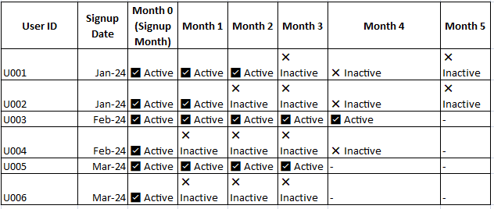

### **Step 2: Define User Cohorts**

* A **cohort** is a group of users who signed up in the same month.
* Example cohorts:
  + **January Cohort**: Users who signed up in January.
  + **February Cohort**: Users who signed up in February

### **Step 3: Track User Activity**

* A user is **active** if they make at least **one transaction** in a given month.
* Retention is measured by tracking how many users from each cohort continue using the app in subsequent months.

**Create a Cohort Retention Table**

| **Signup Month** | **Month 0 (Signup)** | **Month 1** | **Month 2** | **Month 3** | **Month 4** | **Month 5** |
| --- | --- | --- | --- | --- | --- | --- |
| **Jan 2024** | 10,000 users | 6,500 | 5,200 | 4,100 | 3,200 | 2,500 |
| **Feb 2024** | 12,000 users | 7,200 | 5,800 | 4,600 | 3,800 | - |
| **Mar 2024** | 11,000 users | 7,000 | 5,600 | 4,500 | - | - |

### **Step 4: Calculate Retention Rate**

The Monthly Retention Rate formula:

**Retention Rate = (Active Users in Month N / Total Users in Cohort) x 100**

Example Calculation for January Cohort:

* Month 1 Retention Rate: (6,500 / 10,000) x 100 = 65%

* Month 2 Retention Rate: (5,200 / 10,000) x 100 = 52%

* Month 3 Retention Rate: (4,100 / 10,000) x 100 = 41%

### **Step 5: Analysis of Retention Patterns**

📊 **Visualizations:** Visualizing the Data 📊

1️⃣ Line Chart – Retention Trends Over Time

What it shows: The retention rate per cohort over time.

Insight: Retention drops sharply after Month 1.

Action: Focus on improving Month 1 engagement.

Line Chart:

📉 Retention Over Time

X-axis: Months

Y-axis: Retention Rate (%)

Different lines for each cohort

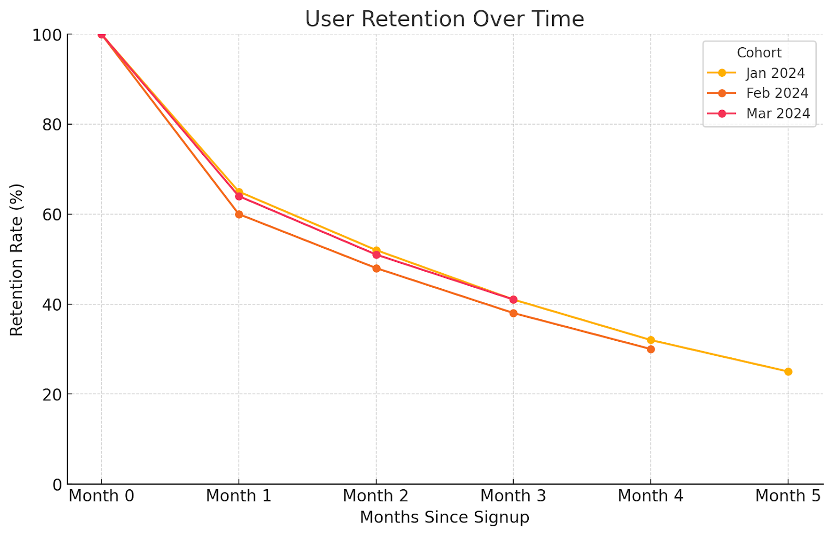

### **2️⃣ Heatmap – Visualizing Drop-off Points**

| **Signup Month** | **Month 0** | **Month 1** | **Month 2** | **Month 3** | **Month 4** | **Month 5** |
| --- | --- | --- | --- | --- | --- | --- |
| **Jan 2024** | **100%** | **65%** | **52%** | **41%** | **32%** | **25%** |
| **Feb 2024** | **100%** | **60%** | **48%** | **38%** | **30%** | - |
| **Mar 2024** | **100%** | **64%** | **51%** | **41%** | - | - |

🔹 **Interpretation**:

* Darker colors in **Month 1** highlight the biggest drop.
* Lighter colors in **later months** indicate stabilization.

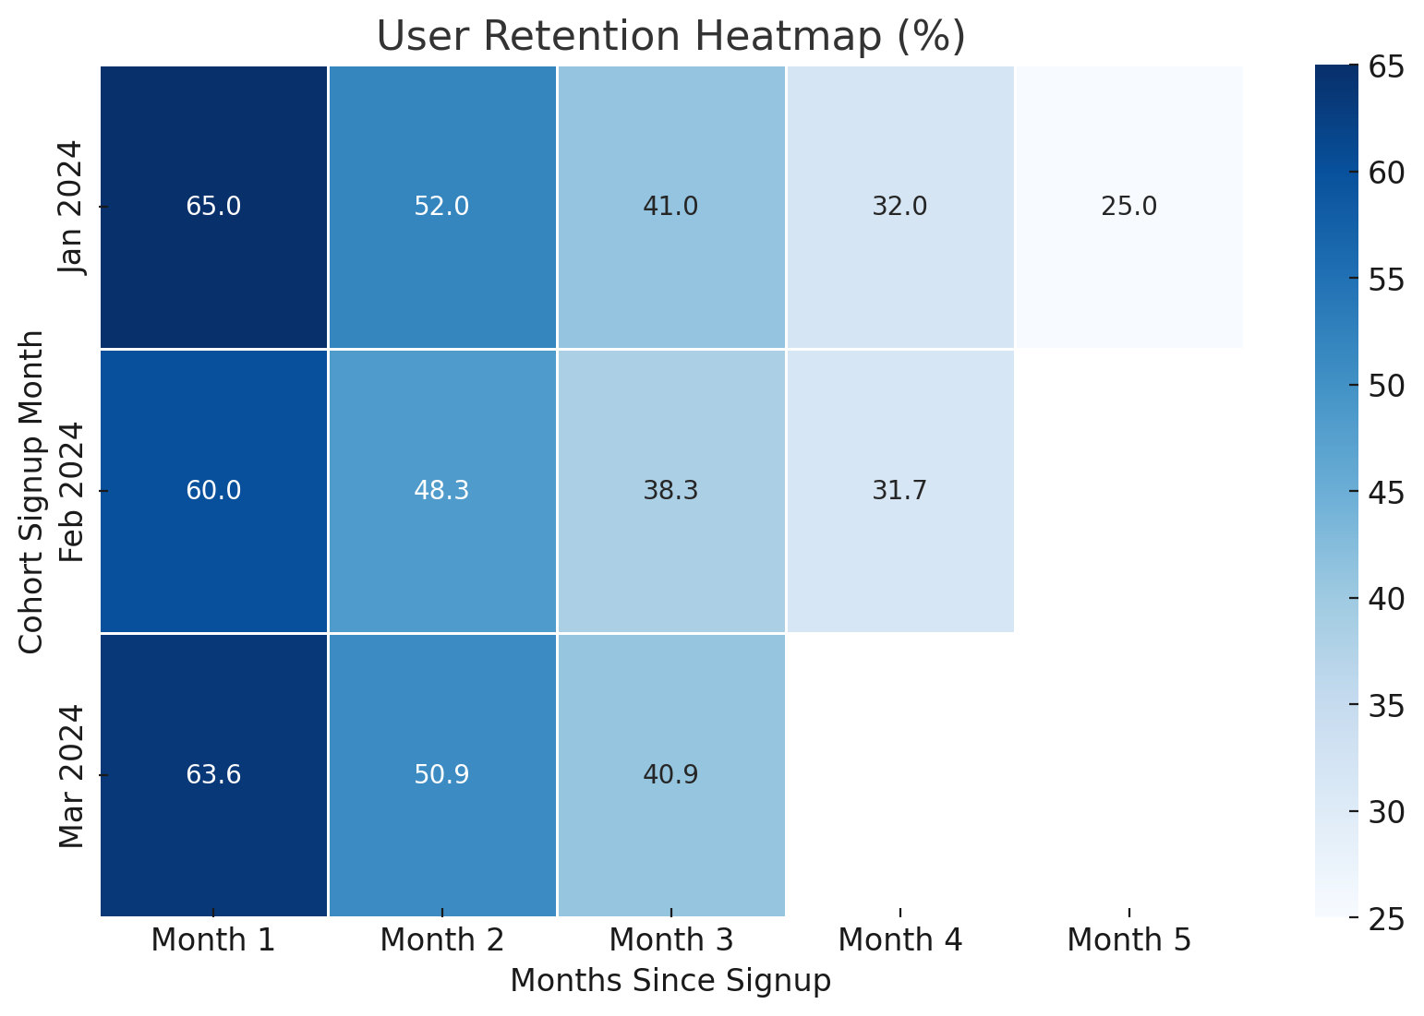

### **Step 6: Actionable Insights**

🔹 **Key Observations:**

* Most users drop off after Month 1 (largest retention decline).
* Retention stabilizes in later months, suggesting engaged users continue.

🔹 **Feedback:**

1. **Improve Onboarding Experience** – Provide tutorials and incentives for first-time users.
2. **Personalized Engagement** – Send reminders, cashback offers, and push notifications to inactive users.
3. **Loyalty Programs** – Encourage repeat transactions through rewards and referral bonuses.
4. **Feature Enhancements** – Analyze drop-off reasons and introduce features users find value

A fintech company offers a **mobile payment app** that allows users to link their bank accounts and make payments. The company wants to analyze the **retention of users who signed up in the past six months** to understand how often they continue using the app after their initial download.

### **Question 2: Addressing the Significant Drop in Retention After the First Month**

#### **Observations from Cohort Analysis**

* The biggest **drop-off occurs between Month 0 and Month 1**.
* Users **sign up but do not return after their first transaction**.

### **Possible Reasons for the Drop-off**

**1. Poor Onboarding Experience**

* Users **don’t understand** how to use the app.
* **Confusing UI** or too many steps to link a bank account.
* **Lack of initial guidance** on how to make transactions.

**2. Lack of Engagement & Incentives**

* No reason to **return to the app** after the first transaction.
* **No rewards, cashback, or referral programs** to encourage repeat use.

**3. Security & Trust Concerns**

* Users hesitate to **link bank accounts** due to security concerns.
* Fear of **fraud, hidden charges, or scams**.

**4. Competition from Other Fintech Apps**

* Other apps offer **better rewards, lower fees, or superior user experience**.

**5. Technical & Performance Issues**

* **Slow transactions, app crashes, or frequent logouts** frustrate users.

## **Strategies to Improve Retention**

To **increase Month 1 retention**, we need to **improve user experience, engagement, and incentives**.

### **1. Enhance User Onboarding**

Make the first-time user experience smooth and engaging.

* **Guided Tutorials**: Walk users through linking their bank and making the first payment.
* **Personalized Setup**: Ask about user preferences and suggest features.
* **Instant Customer Support**: Provide chatbot or live chat for new users.

### **2. Implement Engagement Strategies**

Keep users active with notifications and gamification.

### **3. Offer Incentives to Increase Retention**

Encourage repeat usage through discounts and rewards.  
 **Referral Programs**: "Invite a friend and earn ₹100 cashback!"  
 **Second Transaction Offer**: Reward users for making another payment within 7 days.

### **4. Build User Trust & Address Security Concerns**

Make users feel safe linking their bank accounts.

### **5. Improve App Performance**

**Fix Bugs & Optimize Speed**: Reduce crashes and ensure fast transactions.

## **Final Recommendation**

To **improve retention**, fintech companies should:

**1.Enhance onboarding** with interactive tutorials and live support.  
2. **Engage users** with push notifications and gamification.  
3.**Offer incentives** like cashback and referral rewards.  
4. **Build trust** with security features and testimonials.  
5. **Improve app performance** by fixing bugs and optimizing UX/UI.

By focusing on **Month 1 retention strategies**, the company can **reduce drop-offs, increase engagement, and drive long-term user retention**.

#### **Scenario 2:**

The fintech company is testing two different loan approval notification designs. Version A is a simple approval message, while Version B includes additional loan details (e.g., repayment options, interest rate, and payment reminders). They want to see which design leads to more loan acceptance.

**Question 1:**How would you structure an A/B test to measure the impact of these notification designs on loan acceptance rates?

* **Hint:** Track loan acceptance rates (percentage of users who accept the loan offer), average loan amount, and repayment behaviors after loan acceptance.

## 

## **Scenario 2: A/B Testing Loan Approval Notifications**

A fintech company is testing two versions of loan approval notifications:

* **Version A:** A simple approval message.
* **Version B:** A detailed message including loan details like repayment options, interest rates, and payment reminders.

The goal is to determine which version leads to higher loan acceptance rates.

To measure the impact of notification designs on loan acceptance rates, we will conduct an **A/B test** using the following steps:

### **1. Define Key Metrics to Measure**

The primary metrics to track include:

* Loan Acceptance Rate
* Loan Acceptance Rate = (Number of loans accepted / Total number of loan offers sent) × 100
* Average Loan Amount (mean value of accepted loans).
* Repayment Behavior (on-time payments, defaults, early repayments).

### **2. Randomly Assign Users to Groups**

* **Group A (Control):** Receives **Version A** (simple approval message).
* **Group B (Test):** Receives **Version B** (detailed loan information).
* Ensure users are **randomly assigned** to avoid bias.

### **3. Ensure Sufficient Sample Size**

* You can use different methods to find the sample size e.g. **power analysis**.
* Factors to consider:
  + Expected effect size (e.g., a 5%-10% increase in loan acceptance).
  + Confidence level (typically **95%**).
  + Statistical power (typically **80%**).

Example: If the baseline loan acceptance rate is 20%, and we expect Version B to increase it to 22%, we need a large enough sample to detect this difference with statistical significance.

### **4. Conduct the A/B Test**

* **Deploy notifications** for a fixed period (e.g., 1 month).
* **Monitor the loan acceptance rate** for both groups.
* **Collect data** on additional metrics:
  + Loan amounts.
  + Repayment behaviors (e.g., missed payments, on-time payments).

### **5. Analyze Results**

* Compare **loan acceptance rates** between Group A and Group B.
* Use **statistical tests** to determine if differences are statistically significant.
* Visualize the results using:
  + **Bar charts** for acceptance rates.
  + **Line graphs** to track changes over time.
  + **Cohort analysis** to see if repayment behavior differs between the groups.

### **6. Make a Decision**

* If **Version B** significantly improves acceptance rates, consider implementing it.
* If the difference is marginal or if repayment behavior worsens, **reassess the messaging strategy**.

**Question 2:  
Suppose Version B (detailed notification) results in a 10% increase in loan acceptance rates but requires additional resources to implement. How would you evaluate whether the increase in acceptance rates justifies the added complexity?**

**Solution:**

Version B increases loan acceptance rates by **10%**, but it requires additional resources to implement. To decide whether the increase is justified, we conduct a **cost-benefit analysis**.

### **1. Calculate the Additional Revenue from Version B**

#### **Assumptions:**

* **Loan amount per user:** $10,000
* **Interest rate:** 10% annually
* **Loan tenure:** 1 year
* **Users receiving loan offers per month:** 10,000
* **Baseline (Version A) acceptance rate:** 20%
* **Version B acceptance rate:** 22% (**10% relative increase**)

#### **Revenue Calculation:**

Revenue per loan:

* Interest Amount = Loan Amount × Interest Rate

= 10,000 x 10% = 1,000

* Incremental loans accepted due to Version B:

(22% - 20%) x 10,000 = 200 additional loans per month

* Incremental revenue per month:

200 x 1,000 = 200,000

* Annual incremental revenue:

200,000 x 12 = 2.4 million

### **2. Cost-Benefit Analysis**

**Estimated Costs of Implementing Version B:**

• Development costs (UI/UX design, engineering updates) = $50,000 (one-time cost)

• Additional customer support inquiries = Minimal (assumed negligible)

• Risk of increased defaults = Not measured in this case

**Net Benefit Calculation:**

Net Benefit = Incremental Annual Revenue - Implementation Cost

= 2.4M - 50K = 2.35M

### **3. Additional Considerations**

* **Break-even analysis:**
  + Determine the minimum increase in acceptance rate required to offset costs.
* **Long-term impact:**
  + If Version B **improves customer experience**, it may lead to **higher retention**.
  + If it **confuses users**, it could lead to **higher default rates**, offsetting revenue gains.
* **Regulatory and Compliance Checks:**
  + Ensure Version B follows financial regulations for loan disclosures.

### **Final Recommendation:**

If **default rates remain stable** and the increase in loan acceptance leads to a significant revenue boost, **Version B should be implemented**. However, the company should continue monitoring long-term repayment behaviors to ensure sustainability.

### **Conclusion**

By conducting an A/B test and performing a **cost-benefit analysis**, the company can make a data-driven decision on whether the additional complexity of Version B is worth the increase in loan acceptance.